# UCS1512 – Microprocessors Lab

# 8 BIT ARITHMETIC OPERATIONS

Exp no : 1 Name: Sreedhar V

Date : 21-08-2020 Reg no: 185001161

# AIM:

To program and execute the 8 bit arithmetic operations like addition, subtraction, multiplication and division in 8086 using an emulator.

# Procedure for executing MASM:

* Install and run DOSBox and mount the masm folder to a drive in DOSBox.
* Go to the mounted drive.[usually d is used]
* Save the 8086 program with extension .asm in the same folder using command “edit”.
* After creating the file, assemble it using the command “masm filename.asm”.
* Link the file using the command “link filename.obj;”.
* Use debug command with filename.exe to execute and analyse the memory contents – “debug filename.exe”.
* In debug, the command “u” will display the unassembled code.
* Use command “d segment:offset” to see the content of memory locations

starting from segment:offset address.

* To change the value in memory, use the command “e segment:offset”. To stop editing, press enter.
* Verify the memory contents to ensure the updates using command “d”.
* Execute using the command “g” and check the outputs.
* Use command “q” to exit from debug and command “exit” from command prompt to close DOSBox.

# Bit Addition:

## Algorithm:

* + Program is set to run from any specified memory position.
  + Load data from opr1 to register AL (first number)
  + Load data from opr2 to register BL (second number)
  + Add these two numbers (contents of register AL and register BL)
  + Initialise carry to 0.
  + Jump to final steps if there is no carry.
  + Increment carry.
  + Store additional values to result.
  + Terminate the program.

## Program:

|  |  |
| --- | --- |
| CODE | COMMENT |
| ;Program for adding 2, 8 bit numbers assume cs:code,ds:data  data segment  opr1 db 11h opr2 db 99h result db 00H carry db 00H  data ends  code segment  org 0100h start:  mov ax,data mov ds,ax mov ah,opr1 mov bh,opr2 mov ch,00h add ah,bh  jnc here  inc ch  here:  mov result,ah mov carry,ch mov ah,4ch  int 21h  code ends end start | Data segment initialized  opr1 initialised and set to 11 opr2 initialised and set to 99  result initialised and set to 00 carry initialised and set to 00  Code segment begins  Originating address is set at 0100  Address of data segment moved to ax From ax, transferred to ds  Value of opr1 transferred to ah Value of opr2 transferred to bh ch is initialised and set to 0 Addition takes palce  Junction created   * Jump if no carry * Else increment ch   data transferred from ah to result  data transferred from ch to carry  Program terminates |

Snapchat of the program:

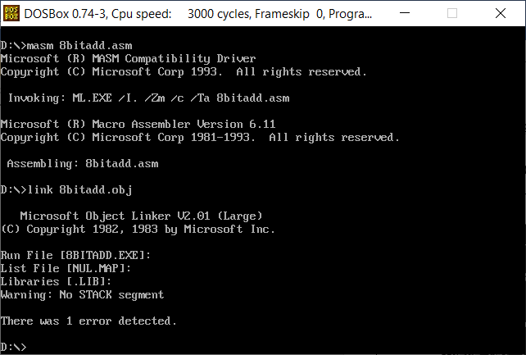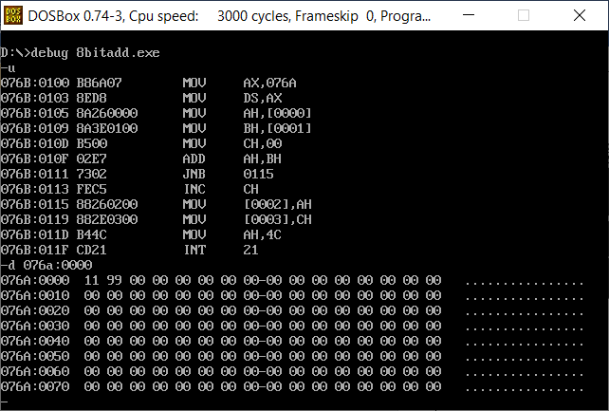

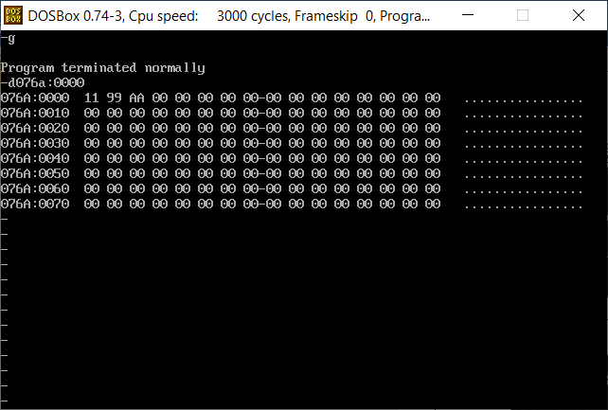

Result:

8 bit addition is executed and verified using an emulator.

# Bit Subtraction:

## Algorithm:

* + Program is set to run from any specified memory position.
  + Load data from opr1 to register AL (first number)
  + Load data from opr2 to register BL (second number)
  + Subtract these two numbers (contents of register AL and register BL)
  + Initialise carry to 0.
  + Jump to final steps if there is no carry.
  + Increment carry.
  + And the result is negated.
  + Store answer to result.
  + Terminate the program.

Program:

|  |  |
| --- | --- |
| CODE | COMMENT |
| Program for Subtracting 2, 8-bit numbers  assume cs:code,ds:data data segment  opr1 db 11h  opr2 db 99h result db 00H carry db 00H  data ends  code segment  org 0100h  start:  mov ax,data mov ds,ax  mov ah,opr1 mov bh,opr2 mov ch,00h  sub ah,bh  jnc here  neg ah  inc ch  here:  mov result,ah mov carry,ch mov ah,4ch int 21h  code ends end start | Data segment initialized opr1 initialised and set to 11 opr2 initialised and set to 99  result initialised and set to 00 carry initialised and set to 00  Code segment begins  Originating address is set at 0100  Address of data segment moved to ax From ax, transferred to ds  Value of opr1 transferred to ah  Value of opr2 transferred to bh    ch is initialise and set to 0  Substarction takes palce  Junction created   * Jump if no carry * Else: negate ah and increment ch   data transferred from ah to result  data transferred from ch to carry  Program terminates |

Snapchat of the program:

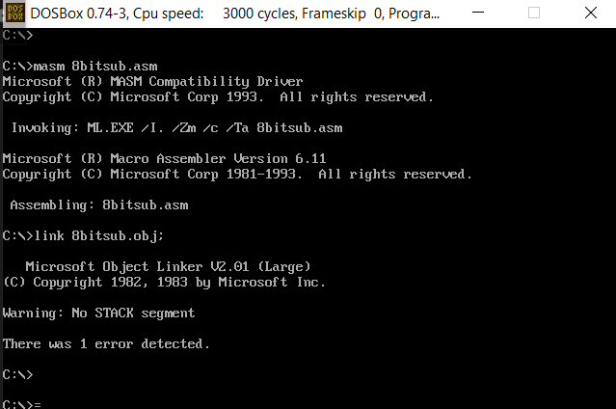

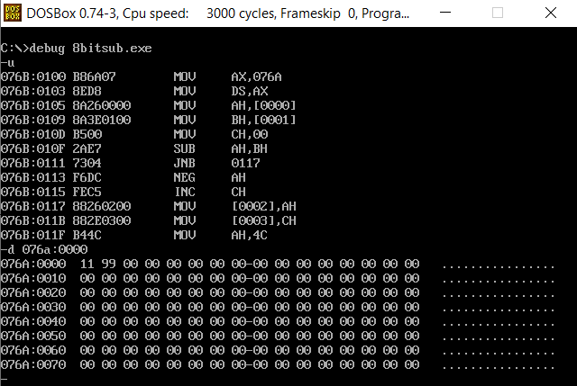

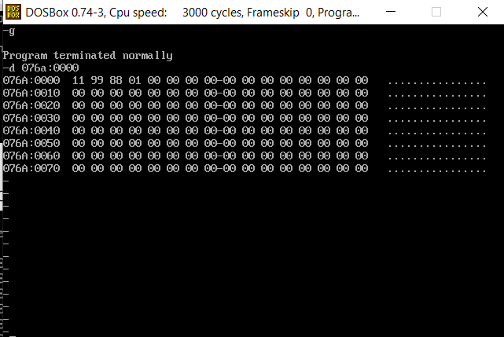

Result:

8 bit subtraction is executed and verified using an emulator.

# Bit Multiplication:

## Algorithm:

* + Program is set to run from any specified memory position.
  + Load data from opr1 to register AL (first number)
  + Load data from opr2 to register BL (second number)
  + Multiply these two numbers (contents of register AL and register BL)
  + Initialise carry to 0.
  + Multiplied values is stored in ah and al
  + These two values are stored in different locations for better representation.
  + Terminate the program.

## Program:

|  |  |
| --- | --- |
| CODE | COMMENT |
| Program for Multiplying 2, 8 bit numbers  assume cs:code,ds:data data segment  opr1 db 11h opr2 db 99h result db 00H res db 00H  data ends  code segment  org 0100h  start:  mov ax,data mov ds,ax mov al,opr1 mov bl,opr2 mul bl  mov result,ah mov res,al  mov ah,4ch  int 21h  code ends end start | Data segment initialized  opr1 initialised and set to 11  opr2 initialised and set to 99  result initialised and set to 00 res initialised and set to 00  Code segment begins  Originating address is set at 0100  Address of data segment moved to ax From ax, transferred to ds  Value of opr1 transferred to al Value of opr2 transferred to bl  Multiply al and bl  data transferred from ah to result data transferred from al to res  Program terminates |

Snapchat of the program:

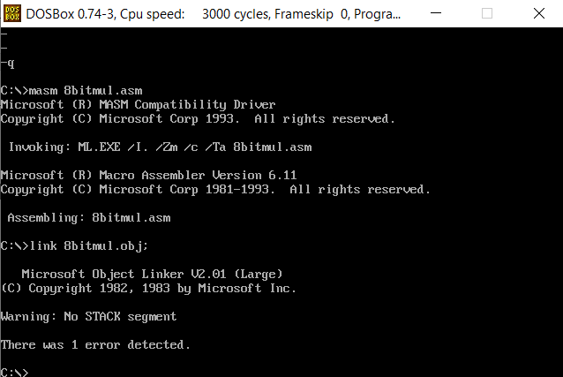

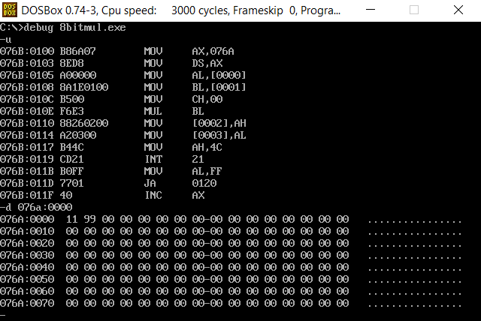

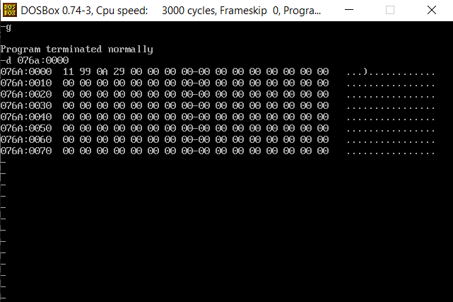

Result:

8 bit multiplication is executed and verified using an emulator.

# Bit Division:

## Algorithm:

* + Load data from opr1 to register AL (first number)
  + Load data from opr2 to register BL (second number)
  + Initialise a variable for remainder to 0.
  + Divide these two numbers (contents of register AL and register BL)
  + Move al value to quotient variable.
  + Move ah value to remainder variable.
  + Terminate the program.

## Program:

|  |  |
| --- | --- |
| CODE | COMMENT |
| ;Program for Dividing 2, 8 bit numbers  assume cs:code,ds:data data segment  opr1 db 99h opr2 db 11h  quotient db 00H rem db 00H  data ends  code segment  org 0100h  start:  mov ax,data mov ds,ax mov ah,00h mov al,opr1 mov bl,opr2 div bl  mov quotient,al mov rem,ah mov ah,4ch  int 21h code ends  end start | Data segment initialized  opr1 initialised and set to 99 opr2 initialised and set to 11  quotient initialised and set to 00 rem initialised and set to 00  Code segment begins  Originating address is set at 0100  Address of data segment moved to ax  From ax, transferred to ds  ah is initialise and set to 0  Value of opr1 transferred to al Value of opr2 transferred to bl Division takes place  data transferred from al to result data transferred from ah to rem  Program terminates |

Snapchat of the program:

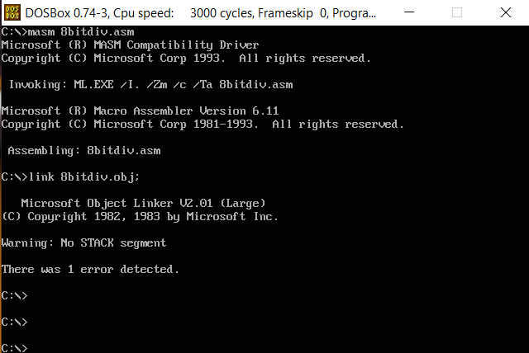

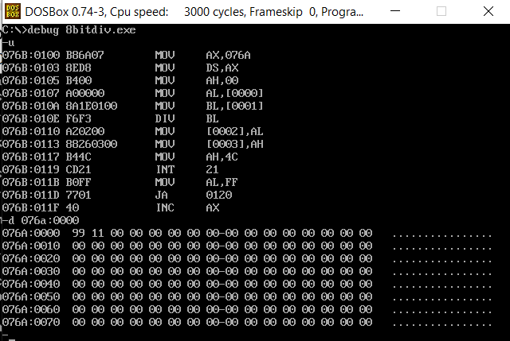

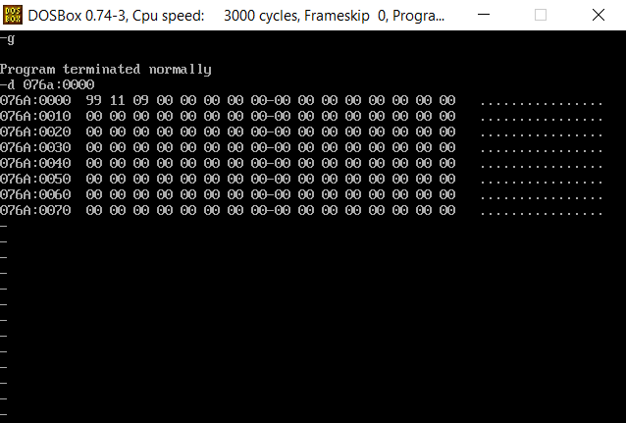

Result:

8 bit division is executed and verified using an emulator.